Live Q&A 1 Transcript
You might find these transcripts less useful as Agi goes through the questions live. It is hard to get all the detail of what she is saying, so I try to word it for my convenience of typing it up.
The questions on week 1 will all be mathematical content. You should be practising as much as you can, just as you would for mathematics.
In this lecture, I will try to talk about how to get the lecture.
I understand this tutorial is supposed to be interactive, but the class is huge, so it’s unrealistic for me to address everyone.
After the tutorial, I will do all the questions eventually. Hopefully with this limited interaction, you still find this tutorial useful.
I will be doing question 1.3, 1.6, 1.7, 1.10.

1.3 How many of the five formulas be made simultaneously true?
We will use two truth tables for A and NOT A
We analyse them one by one (see the colours)
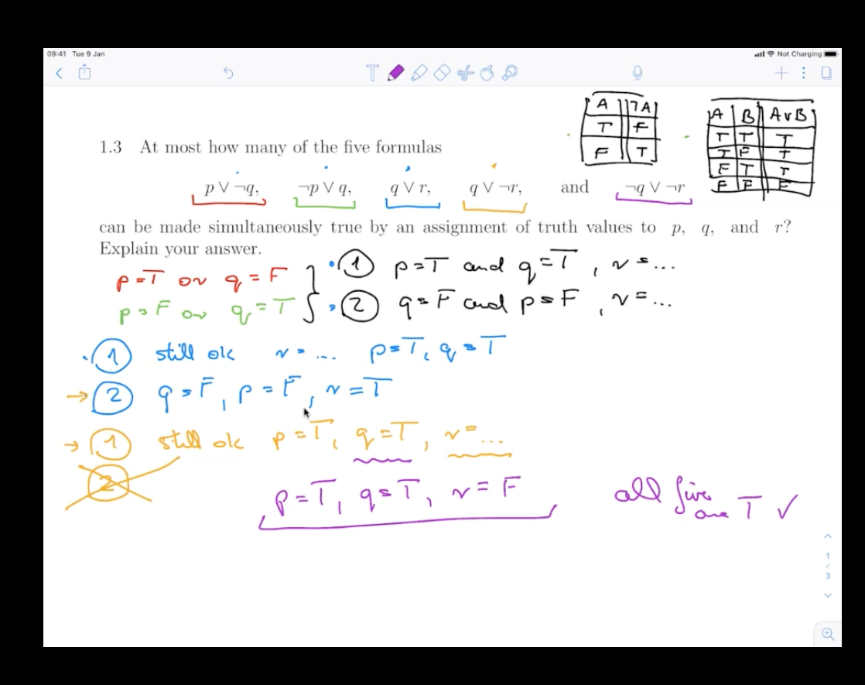

...or just use the truth table.
This method is a lot easier. Don’t bother doing the first method ;)
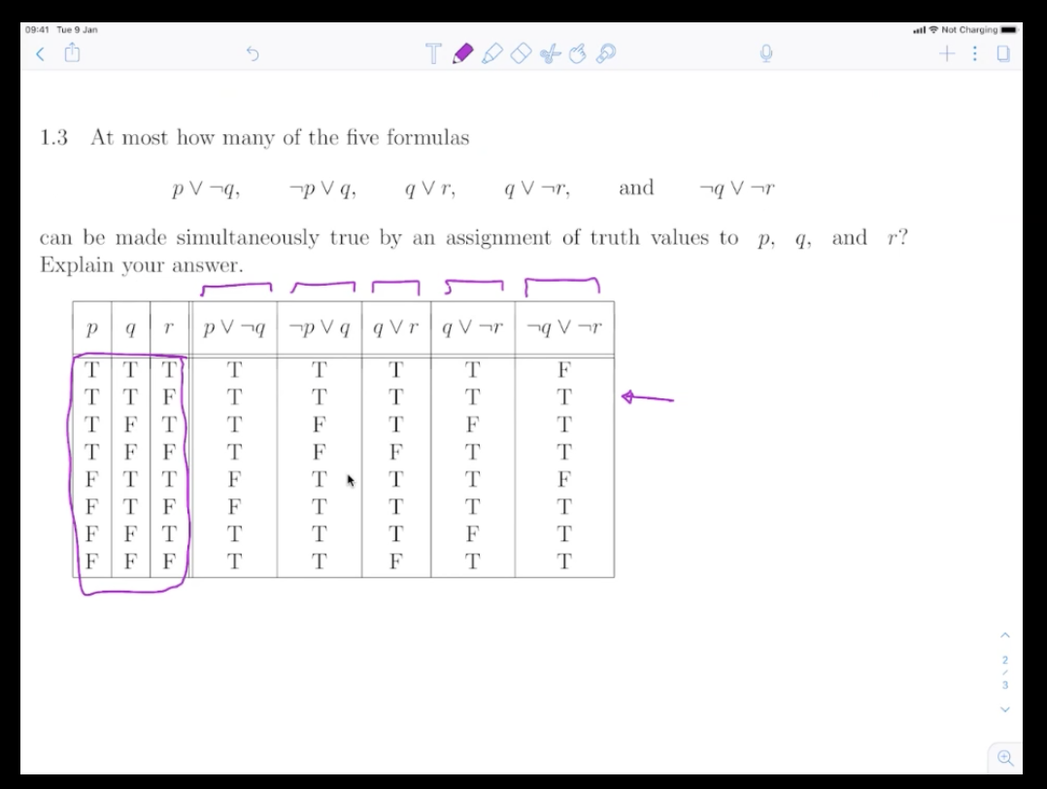

1.6 Formalise the following collection of statements in…
The first task is to formalise and determine whether or not it’s consistent.
To formalise, each and every variable must denote a proposition. Afterwards, you can fit propositional connectives.
You can make a truth table…
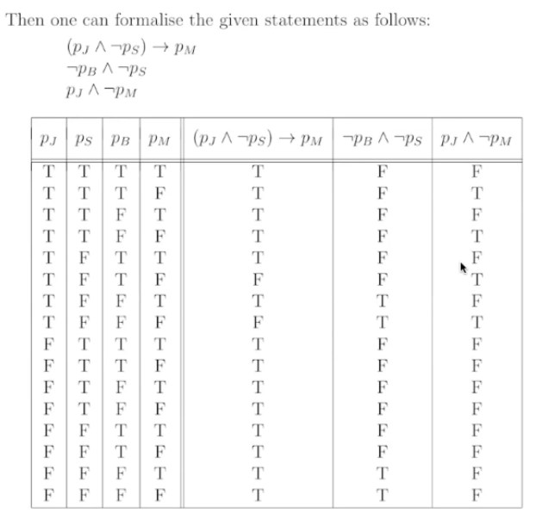

Or just try to think about it. If you try to make the 3rd formula true, the 1st formula can’t be true, therefore the table is not consistent.

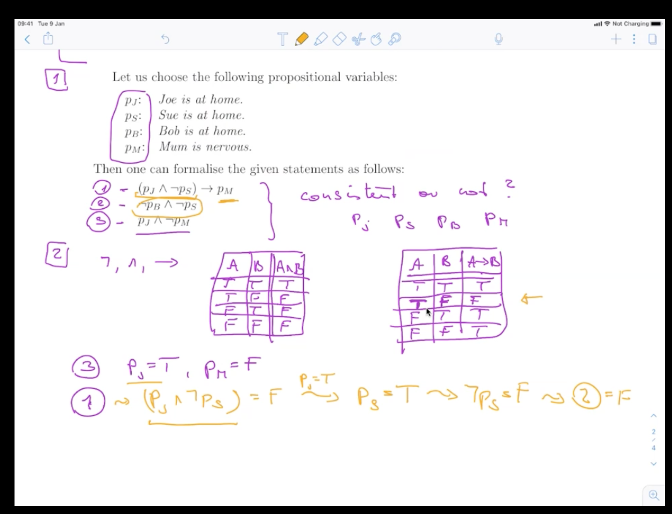

1.7 Raymond Smullyan posed many puzzles about an island that has…
You can answer this with common sense or a truth table. Let’s start with common sense.
What’s B?
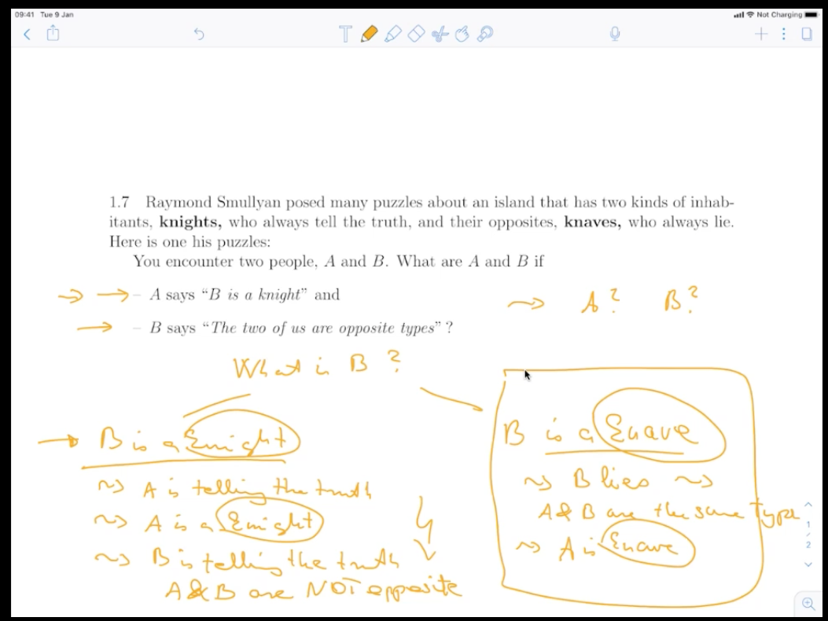
- B is a knight
  - A is telling the truth, therefore A is a knight.
  - B is telling the truth
  - A & B are NOT opposite
- B is a knave
  - B lies
  - A & B are the same type
  - A is a knave
The solution where A and B is a knave is true.
As for the truth table solution:
a: A is a knight
NOT a: A is a knave
b: B is a knight
NOT b: B is a knave
So what are they saying?
A says: b
B says: (a AND NOT b) or (NOT a AND b)
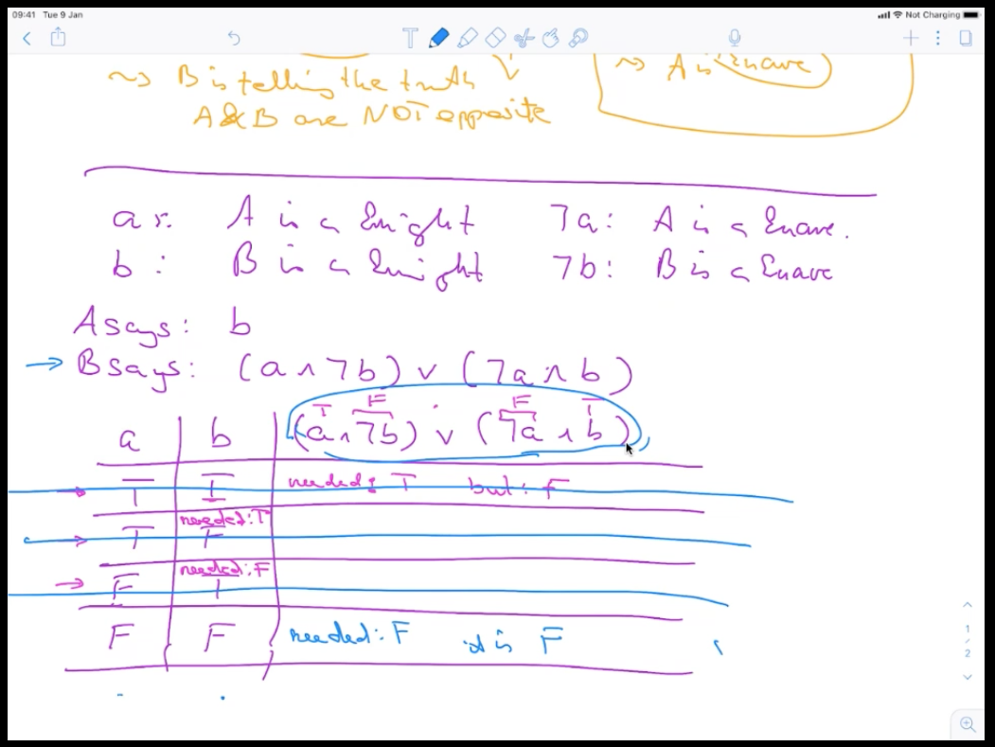
Where A is a knight and B is a knight, the situation is contradictory. Therefore, this can not be false.
Where A is a knight and B is a Knave, B is needed to be true.
Where A is a knave and B is a knight, the situation is contradictory.
Therefore, by process of elimination, both must be knaves.

1.8 Translate these statements into English where R(x) is a rabbit…
There are many solutions to this. Natural language statements like this are much richer.
A
- For every choice of an animal, if the animal in question is a rabbit, then that particular animal hops.
- i.e.: Every rabbit hops.
B
- For every choice of an animal, it is a rabbit that hops.
- i.e: All animals are hopping rabbits
C
- There is an animal such that if it is a rabbit then it hops.
- i.e: There is an animal that either it is not a rabbit, or if it is, then it hops
- This statement is really hard to wrap your head around. Try considering an example, e.g. a fish.
D
- There is such an animal that it is both a rabbit and it also hops.
- i.e: there is a hopping rabbit.

1.10 Show by induction that, for every positive integer n…
Start with the base case.
P(1) : 1=1²
Then continue with the induction cases
P(3): 2_{n} – 1 = 2₃ – 1 = 5 1 + 3 + 5 = 3² = 9
P(4): 2_{n} – 1 = 2₄ – 1 = 7 1 + 3 + 5 + 7 = 4² = 16

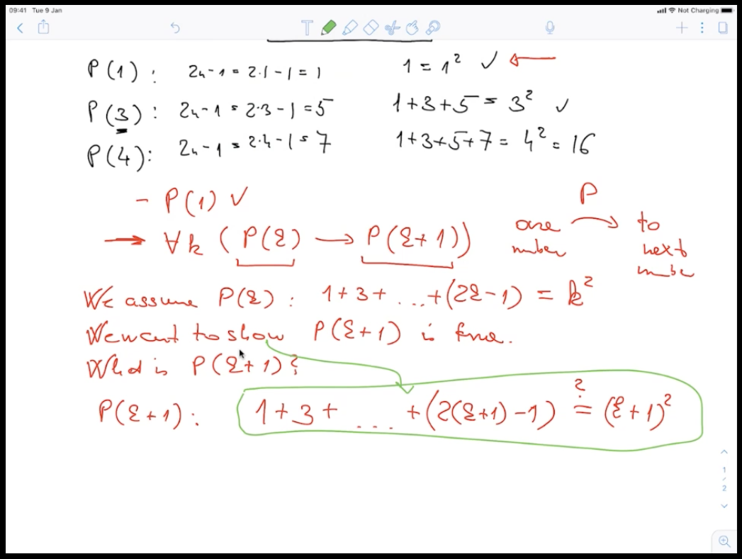

These questions were asked throughout the lecture. I put them all in this page for convenience.

Will you discuss 1.8 and 1.9?
I’m planning to discuss 1.8, but not 1.9.

Will we get answers for the practice work?
I will publish them this afternoon.

I feel like 17 videos is too much for one week.
I agree. In normal times, there were 4 hours of lectures. It’s not me that made it, but it is how it works.

What is the best way to learn proofs?
There is no best way. Just keep at it.

Will we get help with the practice work?
Try to ask questions on KEATS first.

What app am I using to annotate the iPad?
I’m using something called Notability.

When will the recording be available?
As soon as possible

What are you using to denote symbols?
LaTeX

Would it be easier to use XOR for the Knights/Knaves question?
You could, but you don’t have to. I wouldn’t say it’s easier. There are multiple methods, but as long as the question doesn’t ask for specifics, you don’t have to specifically use one method.

